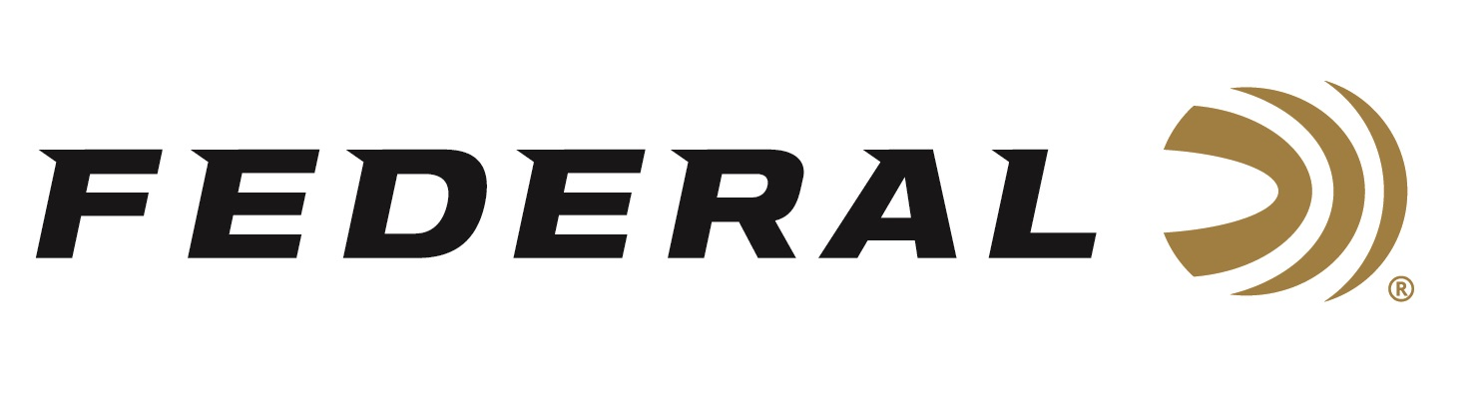

FOR IMMEDIATE RELEASE

Federal Ammunition Introduces New Fusion 10mm Auto
Hunting Loads

ANOKA, Minnesota – October 6, 2020 – Federal ammunition introduces a new load to its popular handgun hunting ammunition lineup. The new Fusion 10mm Auto load uses a 200-grain bullet and 1200 fps muzzle velocity take full advantage of the 10mm Auto cartridge, with more energy and better terminal performance on impact. Shipments of this product have begun to arrive at dealers.

“Our Fusion 10mm Auto load delivers the toughness, accuracy, reliability and terminal performance that handgun hunters are looking for,” said Federal Centerfire Handgun Product Manager Chris Laack. “Built with the same molecularly-bonded hunting bullet used in Fusion rifle ammo, it produces ideal upsets and deep penetration when striking game. We know this new load is everything any hunter could hope for in a 10mm Auto hunting cartridge.”

Features & Benefits
- New 10mm Auto load
- 1,200 fps muzzle velocity
- Copper jacket is electro-chemically to the core
- Perfectly uniform jacket
- Skived, pre-programmed nose provides consistent expansion
- Maximum weight retention for deep penetration

Part No. / Description / MSRP
F10FS1 / 10mm Auto Fusion, 200-grain, 1200 fps, 20-count / $32.99
https://www.federalpremium.com/handgun/fusion/fusion-handgun/11-F10FS1.html

Federal ammunition can be found at dealers nationwide or purchased online direct from Federal. For more information on all products from Federal or to shop online, visit www.federalpremium.com.

Press Release Contact: JJ Reich
Senior Manager – Press Relations
E-mail: VistaPressroom@VistaOutdoor.com

About Federal Ammunition
Federal, headquartered in Anoka, MN, is a brand of Vista Outdoor Inc., an outdoor sports and recreation company. From humble beginnings nestled among the lakes and woods of Minnesota, Federal Ammunition has evolved into one of the world's largest producers of sporting ammunition. Beginning in 1922, founding president, Charles L. Horn, paved the way for our success. Today, Federal carries on Horn's vision for quality products and service with the next generation of outdoorsmen and women. We maintain our position as experts in the science of ammunition production. Every day we manufacture products to enhance our customers' shooting experience while partnering with the conservation organizations that protect and support our outdoor heritage. We offer thousands of options in our Federal Premium and Federal® lines-it's what makes us the most complete ammunition company in the business and provides our customers with a choice no matter their pursuit.

